ECE 383 Final Project Plan – Brandon Sweitzer
Tetris

- Hardware Organization

The game will be implemented as a modular, synchronous VHDL design, organized into separate components that interact through clearly defined signals and a top-level controller.

The Top-Level Structure will consist of:
- Input Subsystem for the NES controller interface
- Game logic subsystem including the FSM, game board, and piece logic
- VGA video output
- Timing with clock dividers to establish the game speed

- Major Hardware Modules

- NES Controller Interface

Reads and decodes player input from NES controller.

Interface will need to:
- Generate latch/clock signals
- Decode button states
- Take serial button data
- Output debounced button signal

- Game state controller

Control flow of the game using FSM with the following states:
- Init
- Idle
- Spawn
- Fall
- Move
- Lock
- Clear
- Game_over

State will determine when pieces move, lock in place, or disappear when a row is cleared as well as progression for score and levelling.

- Grid Storage

Store current state of the Tetris grid handled by a 2D array/grid stored in BRAM or registers where each cell will be marked as occupied/unoccupied.

Grid storage will be able to read current board state for video output, update the board when pieces lock at the bottom, and shift blocks down when rows are cleared.

- Piece Logic

Manages actively falling pieces. Piece logic will have to:
- Generate new pieces
- Track piece position
- Track rotation
- Output coordinates for collision logic and video rendering

- Collision Detection

Ensure piece moves are valid by checking wall boundaries, floor boundaries, and blocking overlap with preexisting blocks.

This module will have to:
- Block illegal moves
- Output when a piece is ready to lock

- Line Clear Logic

Detect and delete full rows. Clear logic will have to:
- Scan board for full rows
- Clear rows and shift higher rows down
- Update game score

- VGA Output

Display game visuals, use Lab 1 code to make:
- Grid
- Active piece
- Locked pieces
- Game UI

- Timing

Controls game speed using clock dividers to:
- Set piece falling rate
- Generate input sampling for controller

Block Design:
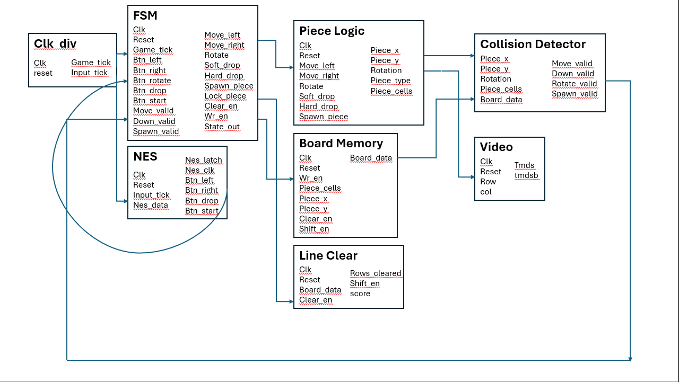

FSM:
